CRAFT DATA STORIES

[DATA VISUALIZATIONS WITH TABLEAU](https://www.coursera.org/learn/visualize-data/lecture/sLxV4/data-visualizations-with-tableau)

Learning Objectives

Connecting your objective with your data through insights is essential to data storytelling. In this part of the course, you’ll get acquainted with the principles of data-driven storytelling and learn to craft compelling narratives using Tableau's dashboard and filtering capabilities, giving life to your data insights.

### Learning Objectives

* Explain data-driven stories, including reference to their importance and their attributes
* Demonstrate an understanding of how to use Tableau to create dashboards and dashboard filters
* Explain how data stories can be used in different forms of on-the-job communication

DATA-DRIVEN STORYTELLING

[Craft Stories With Data](https://www.coursera.org/learn/visualize-data/lecture/tF68H/craft-stories-with-data)

Storytelling is the oldest form of teaching. Humans have been sharing knowledge through stories for tens of thousands of years, back when TVs and computer screens were the walls in a cave. In fact, scientists have confirmed that cave paintings were created by early humans who used their art to convey the stories of their imaginations.

Today, storytelling is still the most natural form of education. That's because stories make learning easier by helping us process and remember information. Everyone tells stories, even if we're just sharing how our day went with a friend.

Many experts believe that human brains automatically organize events with a beginning, a middle, and an end. Thinking about things in this way, like stories, helps us make sense of the past, the present, and the future. On top of that, stories also help us relate to other people and create important human connections. It's no wonder that people are so captivated by stories.

Over the course of history, many important inventions have changed how stories are told. For example, the invention of the printing press led to newspapers, magazines, and books. The invention of the motion picture camera made movies possible, and soon we had TV, videos, on demand, and streaming services that let us enjoy all kinds of stories anywhere, anytime. The invention of data visualization tools changed the way people tell stories once again.

As you've learned, data visualization is the representation and presentation of data to help with understanding.

Coming up, you'll discover how to use data visualization to transform data into a meaningful story that people connect to and care about. You'll also start working with dashboards and dashboard filters.

**A dashboard is a tool that organizes information, typically from multiple data sets, into one central location for tracking, analysis, and simple visualization through charts, graphs, and maps**. And just like filters and spreadsheets and queries.

**A dashboard filter is a tool for showing only the data that meets a specific criteria while hiding the rest.**

Soon you'll know how to use these tools to tell stories that motivate and persuade people to take action based on the data you present. Finally, you will understand the key attributes of data-driven stories and effective ways to communicate them and all sorts of business situations. Ready to become an expert storyteller? Then let's turn to the next chapter of your data analytics story.

[Bring ideas to life](https://www.coursera.org/learn/visualize-data/lecture/QugHy/bring-ideas-to-life)

Stephen Few, an innovator, author, a teacher, and data visualization expert, once said**," Numbers have an important story to tell. They rely on you to give them a clear and convincing voice."**

Facts and figures are very important in the business world, but they rarely make a lasting impression. **To create strong communications that make people think and convince them to take action, you need data storytelling**.

**Data storytelling is communicating the meaning of a data set with visuals and a narrative that are customized for each particular audience.**

A narrative is another word for a story. In this video, you'll learn about data storytelling steps.

These are: **engage your audience, create compelling visuals, and tell the story in an interesting way**.

Here's an example from the music streaming industry. Some companies send their customers a year in review email. It highlights the songs the users have listened to most and sometimes congratulates them for being a top fan of a particular artist. This is a much more exciting way to share data than just a printout of the customer's activity. It also reminds the listener about how much time they spend enjoying the service, a great way to build customer loyalty.

Here's another example, some ride-sharing companies are using data storytelling to show their customers how many miles they've traveled and how that equals spending less money on gas, reducing carbon emissions and saving time they might otherwise have spent fighting traffic. It makes it really easy for the rider to clearly see the value of the service in the simple and fun visual. Data stories like these keep the customer engaged and make them feel like their choices matter because the companies are taking the time to create something just for them, and importantly, the stories are interesting. Knowing how to reach people in this way is an essential part of data storytelling.

Images can draw us in at a subconscious level. This is the concept of engaging people through data visualizations. So far you've been learning about the importance of focusing on your audience.

Coming up, you'll keep building on that knowledge, you'll discover that there are three data storytelling **steps**, and

**The first step is knowing how to engage your audience.** Engagement is capturing and holding someone's interest and attention. When your audience is engaged, you're much more likely to connect with them and convince them to see the same story you see.

Every data story should start with audience engagement, all successful storytellers consider who's listening first. For instance, when a kindergarten teacher is choosing books for their class. they'll pick ones that are appropriate for five-year-olds. If they were to choose high school level novels, the complex subject matter would probably confuse the kids and they'd get bored and tune out.

**The second step is to create compelling visuals**. In other words, you want to show the story of your data, not just tell it. Visuals should take your audience on a journey of how the data changed over time or highlight the meaning behind the numbers.

Here's an example, let's say a cosmetic company keeps track of stores that buy its product and how much they buy. You could communicate the data to others in a spreadsheet like this, or you could create a colorful visual such as this pie chart, which makes it easy to see which stores are most and least profitable as business partners. That's a much clearer and more visually interesting approach.

Now, **the third and final step is to tell the story in an interesting narrative**. A narrative has a beginning, a middle, and an end. It should connect the data you've collected to the project objective and clearly explain important insights from your analysis. To do this, **it's important that your data storytelling is organized and concise**.

Soon you'll learn how to do that using slides for discussion during a meeting and a formal presentation.

We'll discuss how the content, visuals and tone of your message changes depending on the way you're communicating it. And speaking of business communications, one of the many ways that companies use visualization to tell data stories, is with word clouds. Word clouds are a pretty simple visualization of data.

These words are presented in different sizes based on how often they appear in your data set. It's a great way to get someone's attention and to unlock stories from big blocks of text where each word alone could never be seen. Word clouds can be used in all sorts of ways. On social media, they can show you which topics show up in posts most often, or you can use them in blogs to highlight the ideas that interest readers the most. This word cloud was created using text from the syllabus of this course. It tells a pretty engaging story where data analytics, analysis, SQL and spreadsheets are, unsurprisingly, some of the lead characters. Let's continue turning the pages of your data analytics story. There's lots of action and adventure to come.

[Effective data stories](https://www.coursera.org/learn/visualize-data/supplement/qkE40/effective-data-stories)

In data analytics, **data storytelling** is communicating the meaning of a dataset with visuals and a narrative that is customized for a particular audience. In data journalism, journalists engage their audience of readers by combining visualizations, narrative, and context into data-driven articles. It turns out that data analysts and data journalists have a lot in common! As a junior data analyst, you might learn a few things about effective storytelling from data journalism. Read further to explore the role and work of a data journalist in telling a good story.

**Note:** This reading refers to an article published in *The New Yorker*. Non-subscribers may access several free articles each month. If you already reached your monthly limit on free articles, bookmark the article and come back to this reading later.

## **Take a tour of a data-driven article**



[Ben Wellington](https://www.newyorker.com/contributors/ben-wellington), a contributing writer for *The New Yorker* and a professor at the Pratt Institute, used New York City’s [open data portal](https://nycopendata.socrata.com/Social-Services/311-Service-Requests-from-2010-to-Present/erm2-nwe9?) to track down noise complaints from logged service requests. He analyzed the data to gain a more quantitative understanding of where the noise was coming from and which neighborhoods were the noisiest. Then, he presented his findings in the [Mapping New York's Noisiest Neighborhoods](https://www.newyorker.com/tech/annals-of-technology/mapping-new-york-noise-complaints) article.

First, click the link above to skim the article and familiarize yourself with the data visualizations. Then, join the bus tour of the data! You will be directed to three visualizations (tour stops) to observe how each visualization helped strengthen the overall storytelling in the article.

### **Tour stop 1: setting context**

Earlier in the training, you learned how context is important to understand data. **Context** is the condition in which something exists or happens. Based on the categorization of noise complaints, the data journalist set the context in the article by defining what people considered to be noise.

In the article, review the [combo table and bar chart](https://media.newyorker.com/photos/590965cfebe912338a3758c4/master/w_1600%2Cc_limit/Wellington-noise-ComplaintCounts.jpg) that categorizes the noise complaints. Evaluate the visualization:

**How does the visualization help set the context?**

* The combo table and bar chart is effective in summarizing the noise categories as percentages of the logged complaints. This helps set the context by answering the question, “what is noise?” Notice that the data journalist created a combo table and bar chart instead of a pie chart. With 11 noise categories, a list with a bar chart showing relative proportions is an elegant representation. A pie chart with 11 slices would have been harder to read.

**How does the visualization help clarify the data?**

* If you add the percentages in the categories in the combo table and bar chart, the total is ninety-eight percent. There is a difference of two percent that can’t be accounted for in the visualization. So, rather than clarifying the data, the visualization actually causes a little confusion. One lesson is to always make sure that your percentages add up correctly. Sometimes rounding decimal places up or down causes percentages to be off so they don’t add up to 100%.

**Do you notice a data visualization best practice?**

You learned that a companion table in Tableau shows data in a different way in case some in your audience prefer tables. It appears that the data journalist had the same idea by using a combo table and bar chart.

* **Note:** As a refresher, a companion table in Tableau is displayed right next to a visualization. A companion table displays the same data as the visualization, but in a table format. You may replay the [Getting Creative](https://www.coursera.org/learn/visualize-data/lecture/Eytgs/getting-creative) video which includes an example of a companion table.

### **Tour stop 2: analyzing variables**

After setting the context by identifying the noise categories, the data journalist describes his analysis of the noise data. One interesting analysis is the distribution of noise complaints versus the time of day.

In the article, review the [stacked area chart](https://media.newyorker.com/photos/590965cd1c7a8e33fb38d4ac/master/w_1600%2Cc_limit/Wellington-noise-ComplaintsHours.jpg) for the distribution of noise complaints by hour of the day. Evaluate the visualization:

**How does the visualization perform against the five-second rule?**

* Recall that the five-second rule states that you should understand what is being conveyed within the first five seconds of seeing a chart. We are guessing that this visualization performs quite well! The area charts for loud music and barking dogs help the audience understand that more of these types of noise complaints were made during late night and early morning hours (between 10:00 PM and 2:00 AM). Notice also that the color coding in the legend aligns with the colors in the chart. A chart legend normally has the largest category at the top, but the data journalist chose to order the legend so the largest category, “Loud music or party” appears at the bottom instead. How much time do you think this alignment saved readers?

**How does the visualization help clarify the data?**

* Unlike the visualization from the previous tour stop, this visualization does a better job of clearly showing that all percentages add up to 100%.

**Do you notice a data visualization best practice?**

* As a best practice, both the x-axis and y-axis should be labeled. But, the data journalist chose to include % or A.M. and P.M. with each tick on an axis. As a result, labeling the x-axis “Time of Day'' and the y-axis “Percentage of Noise Complaints” isn’t required. This demonstrates that a little creativity with labeling can help you achieve a cleaner chart.

### **Tour stop 3: drawing conclusions**

After describing how the data was analyzed, the data journalist shares which neighborhoods are the noisiest using a variety of visualizations: [combo table and bar chart](https://media.newyorker.com/photos/590965ceebe912338a3758c2/master/w_1600%2Cc_limit/Wellington-noise-ComplaintsNeighborhoods.jpg), [density map](https://media.newyorker.com/photos/590965cfc14b3c606c1067b0/master/w_1600%2Cc_limit/Wellington-noise-complete.jpg), and [neighborhood map](https://media.newyorker.com/photos/590965d0ebe912338a3758c8/master/w_1600%2Cc_limit/Wellington-noise-WilliamsburgDetail.jpg).

In the article, review the [neighborhood map](https://media.newyorker.com/photos/590965d0ebe912338a3758c8/master/w_1600%2Cc_limit/Wellington-noise-WilliamsburgDetail.jpg) for how close a noisy neighborhood is to a quiet neighborhood. Evaluate the visualization:

**How does the visualization help make a point?**

* The data journalist observed that one of the noisiest neighborhoods was right next to one of the quietest neighborhoods. The neighborhood map is effective in emphasizing this observation as a dark blue area versus a white area.

**How does the visualization help clarify the data?**

* The visualization classifies the data by neighborhood and allows the audience to follow along when the journalist focuses specifically on the Williamsburg, East Williamsburg, and North Side/South Side neighborhoods.

**Do you notice a data visualization best practice?**

* Each neighborhood is directly labeled so a legend isn’t necessary.

## **End of the tour: being inspired**

We hope you enjoyed your tour of a data journalist’s work! May this inspire your data storytelling to be as engaging as possible. For additional information about effective data storytelling, read these articles:

* [What is Data Storytelling?](https://www.nugit.co/what-is-data-storytelling/)
* [The Art of Storytelling in Analytics and Data Science | How to Create Data Stories?](https://www.analyticsvidhya.com/blog/2020/05/art-storytelling-analytics-data-science/)
* [Use Data and Analytics to Tell a Story](https://www.gartner.com/smarterwithgartner/use-data-and-analytics-to-tell-a-story/)
* [Tell a Meaningful Story With Data](https://www.thinkwithgoogle.com/marketing-resources/data-measurement/tell-meaningful-stories-with-data/)

[Speak to your audience](https://www.coursera.org/learn/visualize-data/lecture/gqmrF/speak-to-your-audience)

Welcome back. When you want to communicate something to others, a great story can help you reach people's hearts and minds and make them more open to what you have to say. In other words, stories make people care.

As you learned before, the first of the three data storytelling steps teach us that for a story to be successful, you need to focus on who's listening. Data analysts do this by making sure that they're engaging their audience.

That's what we'll explore together now. First, you need to know your audience. Think back to the example of telling someone a joke they've heard many times before and expecting them to laugh at the punchline. Not likely.

To get the response you're seeking, you've got to understand your audience's point of view. That means thinking about how your data project might affect them. It helps to ask yourself a few questions.

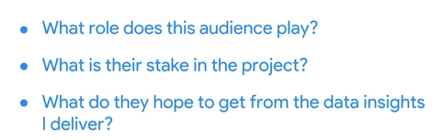

Let's say you're analyzing readership data from customers to help a magazine publisher decide if they should switch from quarterly to monthly issues. If your stakeholder audience includes people from the printing company, they're going to care because the change means they have to order paper and ink more frequently. They also might need to assign more staff members to the project. Or if your stakeholders include the magazine authors and editors, you'll want to keep in mind that your recommendations might change the way they work. For instance, they might need to write and edit stories at a faster pace than they're used to. Once you've considered the answers to those questions, it's time to choose your primary message. Every single part of your story flows from this one key point, so it's got to be clear and direct. With that in mind, let's think about the key message for the data project about our pretend magazine. Maybe the readership data from customers shows that print magazine subscriptions have been going down recently. You discover in survey data that this is mainly because readers feel the information is outdated, so this finding suggests that readers would probably appreciate a publication cycle that gets the information into their hands more often.

But that's not all. Your reader survey data also shows that readers prefer shorter articles with quick takeaways. The data is generating a lot of possible decision points. The volume and variety of information in front of you may feel challenging. To get the key message, you'll need to take a few steps back and pinpoint only the most useful pieces. Not every piece of data is relevant to the questions you're trying to answer.

A big part of being a data analyst is knowing how to eliminate the less important details. One way to do this is with something called spotlighting. **Spotlighting is scanning through the data to quickly identify the most important insights**. There are many ways to spotlight, but lots of data analysts like to use sticky notes on a whiteboard, like how archaeologists make sense of the artifacts they discover in an excavation.

To do this, you write each insight from your analysis on a piece of paper, spread them out, and display them on a whiteboard. Then you examine it. It's important not to get bogged down in every tiny detail. Instead, **look for broad universal ideas and messages. Try to find ideas or concepts that keep popping up again and again or numbers and words that are repeated often. Maybe you're finding things that look like they're connecting or forming patterns. Highlight these items or group them together on your whiteboard**. **Next, explore your discoveries. Find the meaning behind the numbers. The idea is to identify which insights are most likely to help solve your business problem or give you the answers you've been seeking.** This is how spotlighting can lead you to your key message. Remember to keep your key message clear and concise, as an overly-long message like this one shown on screen has less chance of conveying the most important conclusion.

Here's a clear, concise message that's likely to engage your audience because it's short and to the point.

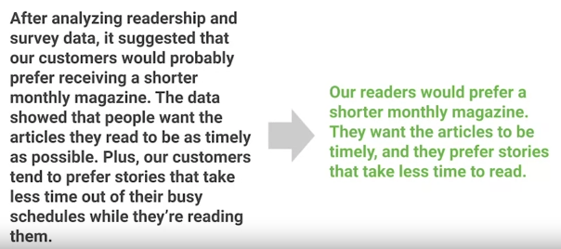

Of course, no matter how much time and effort you put into studying your audience, you can't predict exactly how they'll react to your recommendations. But if you follow the steps we're discussing, you'll be much more likely to have good results. In an upcoming video, you'll learn how to deal with situations that don't go quite according to plan. That's okay. It happens to all of us.

[Carolyn: Data journalism](https://www.coursera.org/learn/visualize-data/lecture/1gN3u/carolyn-data-journalism)

My name is Carolyn, and I'm a measurement lead at Google. And that means that I measure a client's advertising investment and figure out ways that it can perform better for them in the future. Over the course of my career, I've worked in four very different fields, but the thing that links all of them together is **my ability to understand data to get the information that I need out of it and to convey it in a simple and compelling way**.

A really early example of this is from a man named John Snow. He was a doctor in London in the 1850s, and he was living during a cholera outbreak, and the theory at the time was that cholera was spread through the air or "ill humors." People didn't really know what was causing it, but he thought that it was caused by drinking really contaminated and gross water from the Thames. So he went out and interviewed people who were sick and asked them where they got their water, and he found out through mapping the data that they got it all at the same pump. So he went to the authorities and asked them to dismantle the pump, and they took the handle off and the outbreak ended. This started a really robust field of epidemiology, but it also is a great example of data journalism.

Most recently before Google, my job was as a data journalist, and that was to use data to tell stories. I worked at the Chicago Tribune for three years. I worked a lot around the election season and Olympics—big, graphic moments where there's a lot of interesting data and a need to understand it.

The field of data journalism has changed a lot over time, but not as much as you might think. We have a lot more access to data and data that we've never really tracked before, but it's still the job of the data journalists to really understand what that data means. As we have more and more data. It's not really helpful to a reader to just say, "Here's a link to a database." **You still have to uncover the meaning beneath it and really understand what's the insight within the data**.

The tools that a journalist would use to understand something—which is consulting an expert, really diving into a story—are very similar to the tools I need at Google to really understand a media investment and make a really clear recommendation of what someone should do in the future.

My advice is to **understand the tools that are available to you and know how they work, but never to let those tools overwhelm your story**.

So I never want to look at a piece and know this was created using Data Studio or using Microsoft Excel. I want to know what the data says and what a data journalist's point of view is behind that story.

**Don't let the way you create something influence what it's actually saying**.

People just want to know what you've distilled and what new information you've found in all the hard work you've done. I love the field of data journalism because it's just how my brain works. I'm always the type of person who will doodle in the margins or make a quick chart to really understand the data beneath it, and that forces me to find a point of view and to share that with other people. I love that through data, I can communicate with a large audience and really help them understand the world around them.

[Test your knowledge on data-driven stories](https://www.coursera.org/learn/visualize-data/quiz/t2MYc/test-your-knowledge-on-data-driven-stories)

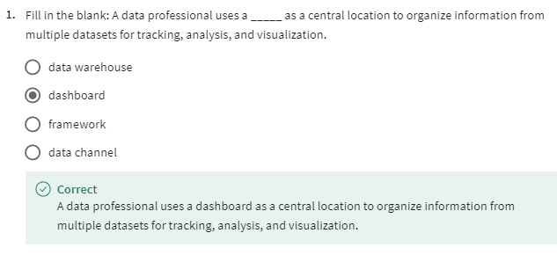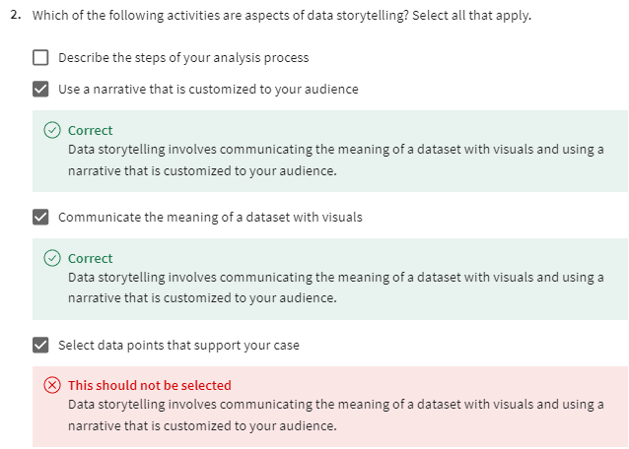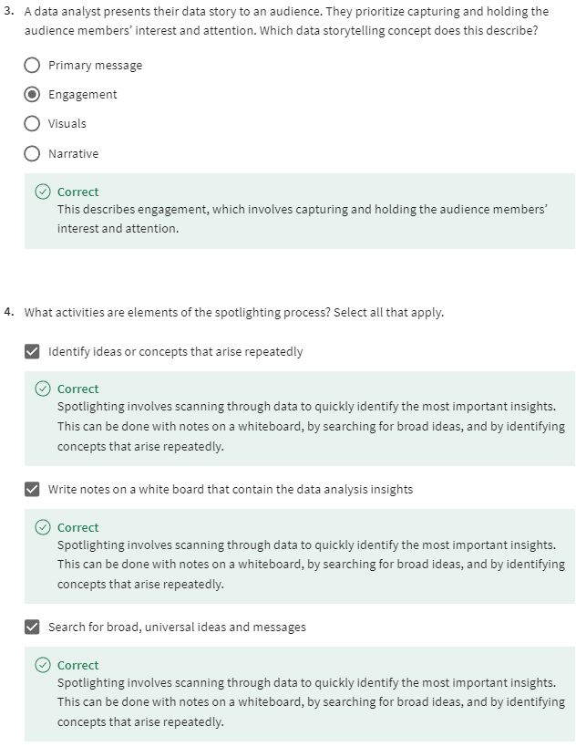

TABLEAU DASHBOARDS

[Tableau dashboard basics](https://www.coursera.org/learn/visualize-data/lecture/qqFMa/tableau-dashboard-basics)

Have you ever been driving a car when one of the warning lights on the dashboard suddenly comes on?

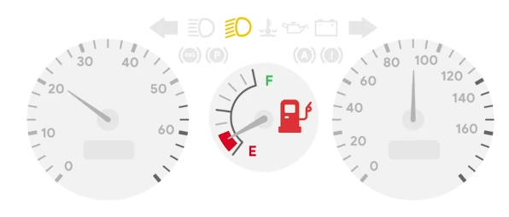

Maybe the gas gauge starts blinking because you're getting low on fuel. It's handy when you have that alert right in front of you, clearly showing you that you need to pay attention to your gas level.

Can you imagine if cars didn't have dashboards? We'd never know if we were about to run out of gas. We'd have no idea if our tire pressure was low or if it was time for an oil change.

Without dashboards, if our cars started acting differently, we'd have to pull out the user manual, sift through all that information inside, and try to figure out the problem ourselves. Car dashboards make it easy for drivers to understand and respond to any issues with their vehicles because they're constantly tracking and analyzing the car status.

But as you've been learning, dashboards aren't just for cars. **Companies also use them to share information, get people engaged with business plans and goals, and uncover potential problems.**

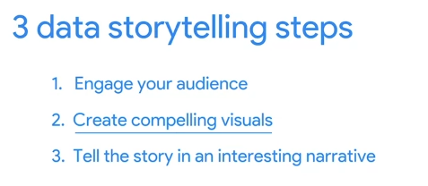

Just like a car's dashboard, data analytics dashboards take tons of information and bring it to life in a clear, visually-interesting way. This is extremely important when telling a story with data, which is why it's a big part of number two in our three data storytelling steps. **You've learned that a dashboard is a tool that organizes information from multiple data sets into one central location for tracking, analysis, and simple visualization through tables, charts, and graphs**.

Dashboards do this by constantly monitoring live incoming data. As we've been discussing, you can make dashboards that are specifically designed to speak to your stakeholders. You can think about who will be looking at the data and what they need from it and how often they'll use it. Then you can make a dashboard with the perfect information just for them. This is helpful because people can get confused and distracted when they're presented with too much data.

A dashboard keeps things neat and tidy and easy to understand.

When designing a dashboard, it's best to start simple with just the most important data points, and if later on you discover something's missing, you can always go back and tweak your dashboard or create a new one.

**An important part of dashboard design is the placement or layout of your charts, graphs, and other visuals. These elements need to be cohesive, which means they're balanced and make good use of the space on the dashboard**.

After you decide what information should be on your dashboard, you might need to resize and reorganize it so it works better for your users. One option in Tableau is choosing between a vertical or horizontal layout.

A vertical layout adjusts the height. A horizontal layout resizes the width of the views and objects it contains. Also, as you can see here, evenly distributing the items within your layout helps create a clear and organized data visual.

You can select either tiled or floating layouts. Tiled items are part of a single-layer grid that automatically resizes based on the overall dashboard size. Floating items can be layered over other objects.

In this example, the map and scatterplots are tiled—they don't overlap.

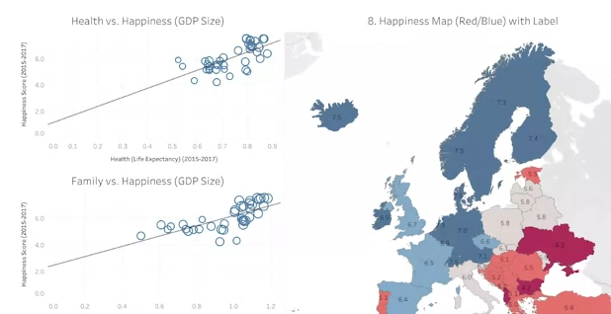

This really helps make clear what the data is all about, **which is valuable because the majority of people in the world are visual learners—they process information based on what they see**. That's why sharing your dashboards with stakeholders is such a valuable practice. Now there's something important to keep in mind about that. Sharing dashboards with others likely means that you'll lose control of the narrative; in other words, you won't be there to tell the story of your data and share your key messages. Dashboards put storytelling power in the hands of the viewer. That means they'll craft their own narrative and draw their own conclusions, but don't let that scare you away from being collaborative and open. Just understand the risks that come with sharing your dashboards. After all, sharing information and resources means that you'll have more people working on the solution to a big problem or coming up with that next big idea. This leads to more connections, which can result in really exciting new practices and innovations.

[Live and static insights](https://www.coursera.org/learn/visualize-data/supplement/vCKv9/live-and-static-insights)

Previously, you learned about data storytelling and interpreting your dataset through a narrative. In this reading, you will explore the difference between live and static insights to make your data even clearer.

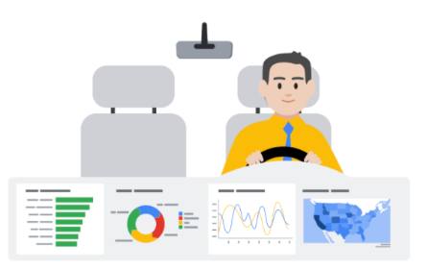

## **Live versus static**

Identifying whether data is live or static depends on certain factors:

* How old is the data?
* How long until the insights are stale or no longer valid to make decisions?
* Does this data or analysis need updating on a regular basis to remain valuable?

**Static data** involves providing screenshots or snapshots in presentations or building dashboards using snapshots of data. There are pros and cons to static data.

**PROS**

* Can tightly control a point-in-time narrative of the data and insight
* Allows for complex analysis to be explained in-depth to a larger audience

**CONS**

* Insight immediately begins to lose value and continues to do so the longer the data remains in a static state
* Snapshots can't keep up with the pace of data change

**Live data** means that you can build dashboards, reports, and views connected to automatically updated data.

**PROS**

* Dashboards can be built to be more dynamic and scalable
* Gives the most up-to-date data to the people who need it at the time when they need it
* Allows for up-to-date curated views into data with the ability to build a scalable “single source of truth” for various use cases
* Allows for immediate action to be taken on data that changes frequently
* Alleviates time/resources spent on processes for every analysis

**CONS**

* Can take engineering resources to keep pipelines live and scalable, which may be outside the scope of some companies' data resource allocation
* Without the ability to interpret data, you can lose control of the narrative, which can cause data chaos (i.e. teams coming to conflicting conclusions based on the same data)
* Can potentially cause a lack of trust if the data isn’t handled properly

## **Key takeaways**

Analysts need to familiarize themselves with the business and data so they can recommend when an updated static analysis is needed or should be refreshed. Also, this data insight will help you make the case for what sorts of analyses, visualizations, and additional data are recommended for the types of decisions that the business needs to make.

Keep this [customer survey spreadsheet](https://docs.google.com/spreadsheets/d/1DWIKPvtci3Gq6Qbz15SjjY6l4wbc_4I-CpVaFDPneDA/template/preview?resourcekey=0-OOpDEJqur_5qsHXNIt2Bqg) on hand as it will be useful for the next video.

[From filters to charts](https://www.coursera.org/learn/visualize-data/lecture/8ls3x/from-filters-to-charts)

So far, we've focused a lot on understanding our audience. Whether you're trying to engage people with data storytelling or creating dashboards designed for a certain person or group, understanding your audience is key.

As you've learned, you can make dashboards that are tailored to meet different stakeholder requirements. To do this, it's **important to think about who will be looking at the data and what they need from it.**

We'll continue exploring how to create compelling visuals to tell an interesting and persuasive data story. **One great tool for doing this is a filter**. You've learned about filters and spreadsheets and queries, but as a refresher, filtering means showing only the data that meets a specific criteria while hiding the rest.

Filtering works the same way with dashboards—you can apply different filters for different users based on their needs.

Tableau lets you limit the data you see based on the criteria you specify. Maybe you want to filter data and the data set to show only the last six months, or maybe you want to see information from one particular customer. You can even limit the number of rows or columns in a view. To explore these options, let's return to our world's happiness example.

Say your stakeholders were interested in only a few of the topics that affect overall happiness. Filtering for just gross domestic product, family, generosity, freedom, trust, and health, and then creating individual scatterplots for each would make this possible.

You can also use filters to highlight or hide individual data points. For instance, if you have a scatter plot with outliers, you may want to explore what your plot would look like without them. However, note that this is just an example to show you how filters work; it's not okay to drop a data point just because it's an outlier.

**Outliers could be important observations, sometimes even the most interesting ones, so be sure to put on your data detective hat and investigate that outlier before deciding to remove it from your dashboard**.

To filter data points from the view, we can choose a single data point or click and drag in the view to select several points. Let's choose just one. Then on the tooltip that appears, we'll select "exclude" to hide it or we could have chosen to do it the other way by keeping only selected data points.

Here's another example. If your data is in a table, you can filter entire rows or columns from your view. To do this, we'll select the rows we want in the view. Then, on the tooltip that appears, we'll choose to keep only those countries. Again, we could have also selected the data points we wanted to exclude and picked that option instead.

Or if you like, we can even prefilter a Tableau dashboard. This means that your stakeholders don't have to filter the data themselves. Basically, by doing the filtering for them, you can save them time and effort and direct them to the important data you want them to focus on.

**Personally, I think the best thing about filters is they let you zero in on what's important**.

Sometimes I'm working with a huge data set, and I want to concentrate only on a specific area, so I'll add a filter to limit the data displayed on my dashboard.

This cuts the clutter and gives me a simple, clear visual. I use filters a lot when working with data about advertising campaign performance. **Filters help me isolate specific tactics**, such a search or YouTube ads, to see which ones are working best and which ones could be improved.

By **limiting and customizing the information I'm looking at, it's much easier for me to see the story behind the numbers**. And as I'm sure you've noticed, I love a good data story.

As a data analyst, you'll often be relying on spreadsheets to create quick visualizations of your data to tell your story.

Let's practice building a chart in a spreadsheet. To follow along, use the spreadsheet link in the previous reading, also included in the video. We'll be using Google Sheets, so this might look a little different in other spreadsheet platforms, like Excel.

We'll begin by filtering just the data on how many customers purchase basic plus or premium software packages.

To start, select the column for the software package and insert a chart. The spreadsheet suggests what it thinks is the best type of chart for our data, but we can choose any type of chart you'd like. Spreadsheet charts also let you assign different styles, access titles, a legend, and many other options. There's lots of different options to choose from.

Let's say we also have data on which countries our customers are from and their overall satisfaction score for the software they purchased. First, highlight columns A and B, then click on "insert" and then "chart" again under "chart type." You want to select the first map option. Voila! Now we have a map that summarizes a customer survey scores by country.

We can also customize this chart by clicking "customize" in the top right corner. Let's say we wanted to change our colors from red and green to a gradient so it's more accessible.

We can do that by clicking "geo" and then change the min color to the lightest shade of blue, the mid color to the middle shade of blue, and the max color to the darkest shade of blue to show the spectrum of scores from low to high.

Now we have a map chart that shows where respondents are most satisfied with their software in dark blue and least satisfied with their software in light blue. And this will be easier for anyone in our audience with color vision deficiencies to understand.

Tableau and spreadsheets are common tools for creating data visualizations. By using their built-in functionalities like filters and charts, you can zero in on what information is most important and create compelling visuals for your audience.

And now that we've explored some ways to create visuals, it's time to start preparing our data narrative. Coming up, we're going to talk more about telling stories with data and organizing presentations. I'll see you soon.

[Hands-On Activity: Create, filter, and customize charts](https://www.coursera.org/learn/visualize-data/quiz/spAfZ/hands-on-activity-create-filter-and-customize-charts)



## **Activity Overview**



You‘ve learned that you can create charts in spreadsheets and in Tableau and that information can be customized using filters. Before working in Tableau, you will work with a spreadsheet chart editor. This will allow you to create visualizations to draw insights from immediately—and will help you start thinking about how to make design choices in more complex tools.

By the time you complete this activity, you will be able to create a chart in a spreadsheet and customize it by using filters and applying different styles. This will enable you to use spreadsheets in another helpful way, which is important for using all the tools at your disposal in your career as a data analyst.



#### Step-By-Step Instructions

Follow the instructions to complete each step of the activity. Then answer the questions at the end of the activity before going to the next course item.

#### Step 1: Access the template

To use the template for this course item, click the following link and select Use Template.

Link to template: [Cosmetics, Inc](https://docs.google.com/spreadsheets/d/1qaSKSyfvXz3Zsu_RU7abK-eNScSyGSe2oXT1KgiaMXI/template/preview)

OR

If you don’t have a Google account, download the template directly from the following attachment.

[Cosmetics Inc.](https://d3c33hcgiwev3.cloudfront.net/cLE2LSPORAeF0QIf1PTY0w_d513d2ff9f974d6d844fb1bea8d690f1_Cosmetics-Inc..xlsx?Expires=1715817600&Signature=ePt7wMRbEIqlvoPWFspyNtz1cMUBCAol4-~f~MN0Qvb9-9XvsB7ZJPBgbB9eT2OH9qKtA~SKbn2u8oNBsa1e5NTL-uXdDa16oQtB9lcbuHGxDqPWTHKmcuDsc0u~QAeve8E~L6VqS28SxX2ffaSAnwzJR02ZTCUB2E8sdfZ9oB8_&Key-Pair-Id=APKAJLTNE6QMUY6HBC5A)

#### Step 2: Create a chart in a spreadsheet

Important note: The following steps are for Google Sheets, but they can help guide you to similar features in Excel. Refer to the Additional resources section if you need more specific instructions for creating charts in Excel.

1. In the spreadsheet that you copied or downloaded, make sure you're working in the first tab named Create your chart here. This tab contains the total purchases calculated for each store from the second tab. All of the original data is preserved in the second tab so you can explore chart creation in the first tab without changing or deleting any of the original data.

2. Select to highlight cells B3 through C7 as the data for your chart.

3. From the main menu, select Insert, and select Chart.

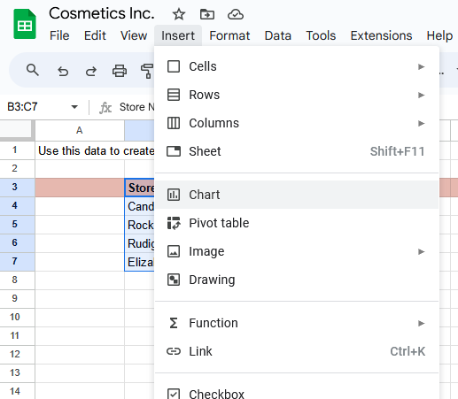

4. A chart is created automatically, and the Chart editor pane opens on the right so you can change the chart type. If a pie chart is displayed, select the Chart type dropdown list and then select a Column chart so your chart matches the one below. Based on the data selected, you should also get a title like the one shown.

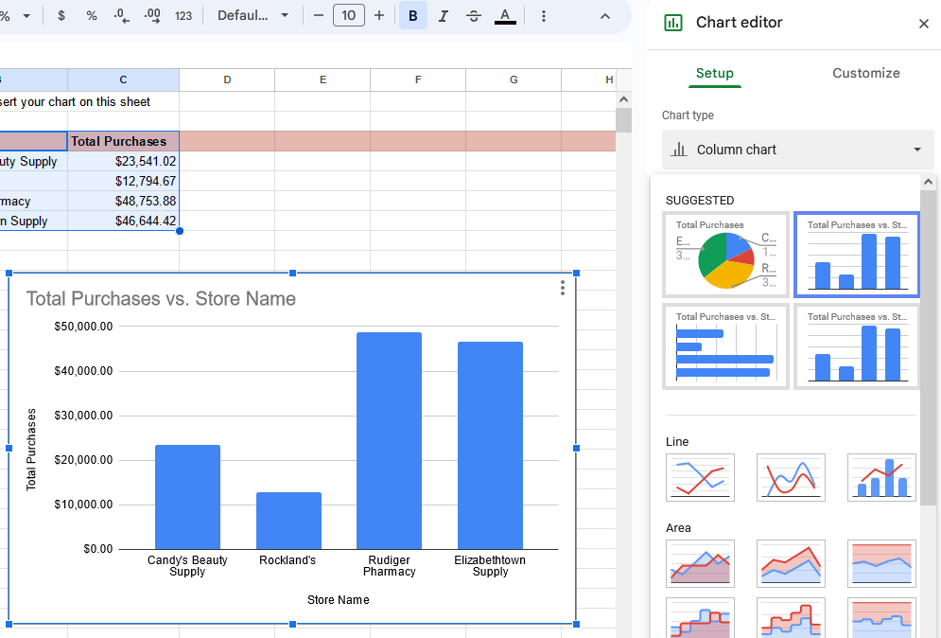

Bars represent Candy’s Beauty Supply, Rockland’s, Rudiger Pharmacy, and Elizabethtown Supply.

5. In the Setup section of the Chart editor, below X-axis, select the three dots menu and then select Add labels. Make sure the range B3:B7 is indicated to the left of the three dots, and after you select the Add labels option, verify that the data columns display a vertical label on each column.

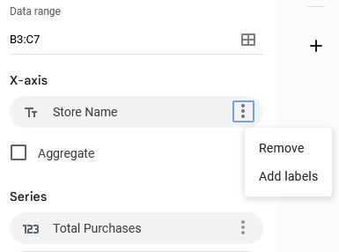

6. To filter the data shown in the column chart, select the pink header row (row 3) and then select the filter icon in the toolbar. This adds a filter icon on each column of your data.

Alternatively, you can use the Data menu and select Create a filter after selecting cells B3:C3.

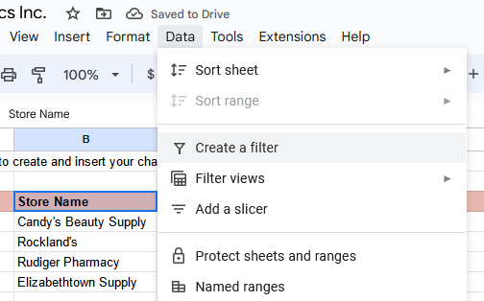

7. Select the filter icon for the Store Name column and uncheck Candy's Beauty Supply.

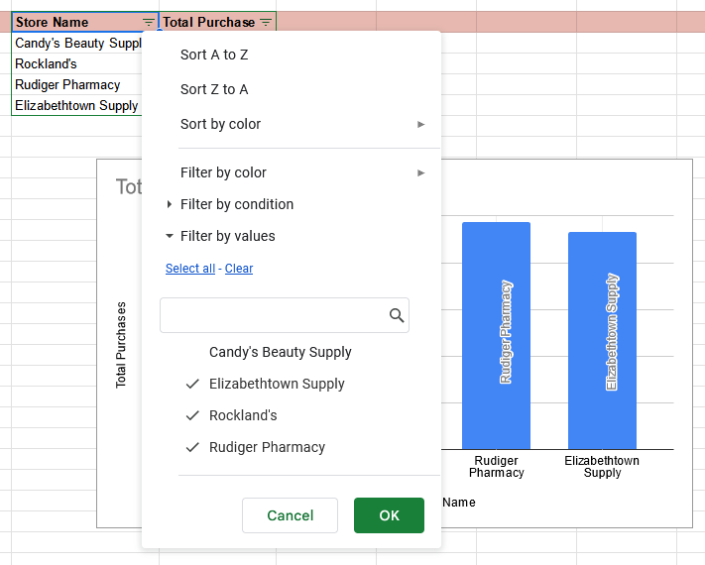

Below these options, a list of the store names allows you to check or uncheck each, allowing you to show each on the chart or not.

8. Select OK and your chart will automatically update to exclude the data for Candy's Beauty Supply, as shown below.

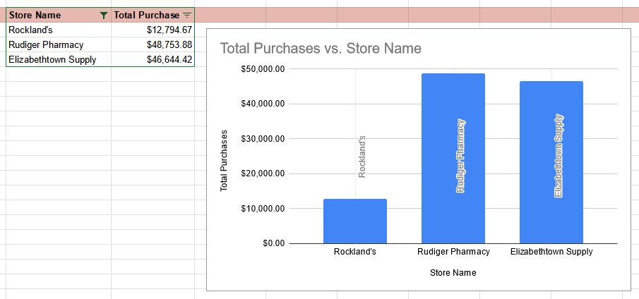

Note: To include the data for Candy's Beauty Supply again, simply select the filter icon for Store Name and then select the Candy's Beauty Supply checkbox to add it back to the chart.

#### Step 3: Apply styles

You can also apply different styles to the chart. For example, the default blue in the chart isn't the most appropriate for accessibility when the background is white.

1. Double-click the chart to open the Chart editor pane.

2. If necessary, in the Chart editor pane, select Series to expand the options.

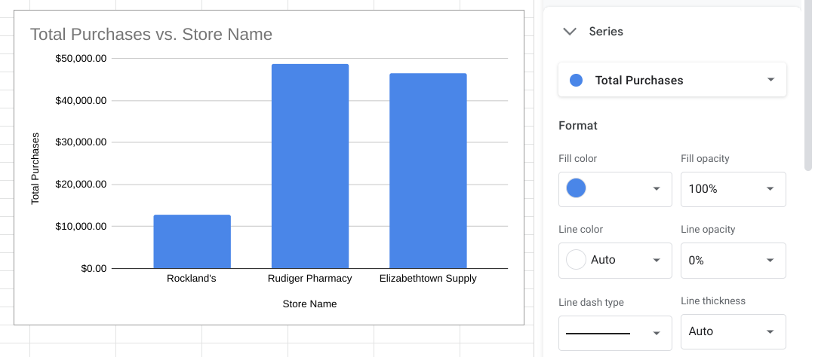

3. Below Format, from the Fill color dropdown list, select Custom.

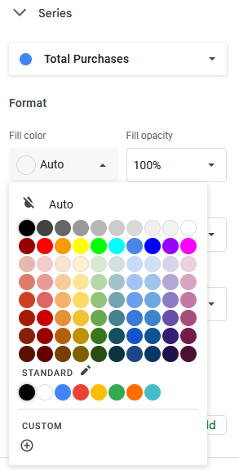

You can also add a custom color at the bottom of the menu.

4. Change the Hex value for the color to one of the blue hues recommended for use on white backgrounds for accessibility. Carnegie Museums of Pittsburgh's [Web accessibility guidelines](http://web-accessibility.carnegiemuseums.org/design/color/) are an example of web accessibility guidelines.

* #0071bc
* #046b99
* #205493

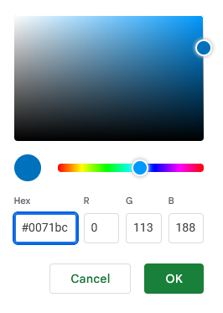

Fields below allow you to enter a Hex value, in this case 0071bc. There are also three fields that allow you to enter values for red, blue, and green to specify a color.

5.Select OK, and the chart will automatically update with the newly assigned color.

#### Step 4: Review resources

Here are a few more resources you can reference as you learn more about charts in spreadsheets:

* [Graphs in Google Sheets](https://www.datacamp.com/community/tutorials/graphs-in-spreadsheets): This resource contains a detailed example of chart creation in spreadsheets and provides downloadable sample data you can use to practice. As you have learned throughout this course, practicing these skills helps you learn more about the tools you are using. This example data is a great way to start!
* [Add and edit a chart or graph in Google Sheets](https://support.google.com/docs/answer/63824): This article includes steps for creating, editing, and changing charts in Google Sheets with how-to videos. It also has a more in-depth guide to editing and customizing your chart after you have created it.
* [Create a Microsoft Excel chart from start to finish](https://support.microsoft.com/en-us/office/create-a-chart-from-start-to-finish-0baf399e-dd61-4e18-8a73-b3fd5d5680c2): This how-to guide from Microsoft’s support site includes instructions and a video tutorial for adding charts to Excel spreadsheets. This is a useful resource if you are working specifically with Excel spreadsheets. It also links to other useful articles about creating charts in Excel.
* [Microsoft Excel: Creating and modifying charts](https://guides.lib.umich.edu/c.php?g=283162&p=1886446): This is an explanation of Excel charts with downloadable handouts. This resource is especially useful because it has downloadable content that you can save to reference later when you start creating charts in your own spreadsheets.

[When to set up a dashboard](https://www.coursera.org/learn/visualize-data/discussionPrompt/agZvM/when-to-set-up-a-dashboard)

[Create your first Tableau dashboard](https://www.coursera.org/learn/visualize-data/supplement/nGpig/create-your-first-tableau-dashboard)

[You're going to take what you've learned about data visualizations and create a dashboard.](https://www.coursera.org/learn/visualize-data/supplement/nGpig/create-your-first-tableau-dashboard)

[Tableau contains tons of other functionality to build dashboards that update in real time and include interactive visualizations.](https://www.coursera.org/learn/visualize-data/supplement/nGpig/create-your-first-tableau-dashboard)

[Dashboards are important in data analysis because they enable people to visualize data in dynamic and interactive ways, which can help enhance what you can do with your data presentations. Data visualizations are most useful when they are presented in a dashboard style format to stakeholders because dashboards put all the key information in the same place, making it easier to understand what's really important. Many dashboards also constantly update to reflect new data and can be interactive. No matter what style of dashboard you choose, they can help you present your data to stakeholders in an impactful way.](https://www.coursera.org/learn/visualize-data/supplement/nGpig/create-your-first-tableau-dashboard)

## **[Open Tableau](https://www.coursera.org/learn/visualize-data/supplement/nGpig/create-your-first-tableau-dashboard)**

[You'll need to navigate and sign-in to the](https://www.coursera.org/learn/visualize-data/supplement/nGpig/create-your-first-tableau-dashboard) [Tableau Public](https://public.tableau.com/app/discover) [online app. You may also refer back to the reading on how to create an account, a profile, loading, and linking datasets using the Tableau public app -](https://www.coursera.org/learn/visualize-data/supplement/nGpig/create-your-first-tableau-dashboard) [Using Tableau Public](https://www.coursera.org/learn/visualize-data/supplement/bMjvq)[.](https://www.coursera.org/learn/visualize-data/supplement/nGpig/create-your-first-tableau-dashboard)

## **[Accessing the Dataset](https://www.coursera.org/learn/visualize-data/supplement/nGpig/create-your-first-tableau-dashboard)**

[Click on the link to create your own copy of the](https://www.coursera.org/learn/visualize-data/supplement/nGpig/create-your-first-tableau-dashboard) [CO2 Dataset](https://docs.google.com/spreadsheets/u/1/d/1LwGHDgJkXSm8b0ziSDyC8pQGqjYVGpX9mAEVPs2KQgY/copy)[.](https://www.coursera.org/learn/visualize-data/supplement/nGpig/create-your-first-tableau-dashboard)

[If you do not have a Google account, you may directly download the CO2 dataset by clicking below:](https://www.coursera.org/learn/visualize-data/supplement/nGpig/create-your-first-tableau-dashboard)

[CO2 Dataset](https://d3c33hcgiwev3.cloudfront.net/EVkUZEQBRjS6Vbihr3z6aQ_eb9289d2c49e46d697fc919a582119f1_CO2-Dataset.xlsx?Expires=1715817600&Signature=JUvL1e5QRSZwjImYQrciyP8tUdXLyLOSIR1nWQGM0mseQ0EF9v1ApfPw1iRDGV-IbTP8FV5w9xqhEh3CvEckUABdSKZkNa1ZAHtIA-oo3m1MMSYWKcWZxzBH1-G0LFOoF13ahsRr534HxlgJ1ZYXz6Z9~Co6N5y7H-u-Xgk3SWU_&Key-Pair-Id=APKAJLTNE6QMUY6HBC5A)

## **[Load the Dataset](https://www.coursera.org/learn/visualize-data/supplement/nGpig/create-your-first-tableau-dashboard)**

1. [Now that you have logged into Tableau Public, access the data source dashboard by clicking on the **Create tab**, then the **Web Authoring** option at the top of the landing page. Next, click on the center button, **Upload from the computer**, and select the CO2 Dataset that has been downloaded to your device.](https://www.coursera.org/learn/visualize-data/supplement/nGpig/create-your-first-tableau-dashboard)
2. [Once the dataset has been loaded, direct your attention to the bottom of the data source tabs in the bottom left corner of the window. This opens the data sources folder Tableau public has created on your machine by default. Going forward, you should save any datasets you're working with to the data sources folder. Keeping your data files in one place is a best practice that will keep you organized.](https://www.coursera.org/learn/visualize-data/supplement/nGpig/create-your-first-tableau-dashboard)
3. [Make a note that all of the tabs within the dataset are arranged into a vertical toolbar on the left side of the page.](https://www.coursera.org/learn/visualize-data/supplement/nGpig/create-your-first-tableau-dashboard)
4. [Drag the Sheet titled **CO2 Data Cleaned** from the left bar to the middle of the page and click on the button **Update Automatically** option after dragging the sheet icon.](https://www.coursera.org/learn/visualize-data/supplement/nGpig/create-your-first-tableau-dashboard)
5. [Navigate back to the tab titled **Sheet 1** at the bottom of the page and click on it. At this point, a new window with a vertical dashboard titled **Tables** will appear.](https://www.coursera.org/learn/visualize-data/supplement/nGpig/create-your-first-tableau-dashboard)
6. [Drag the *green* **# Year** icon to the **Columns** box located at the top of the page.](https://www.coursera.org/learn/visualize-data/supplement/nGpig/create-your-first-tableau-dashboard)
7. [Drag the *green* **# CO2 (kt)** icon to the **Rows** box located at the top of the page.](https://www.coursera.org/learn/visualize-data/supplement/nGpig/create-your-first-tableau-dashboard)
8. [Drag the *blue* **Abc Region** icon to the **Colors** icon containing the 4-colored dots.](https://www.coursera.org/learn/visualize-data/supplement/nGpig/create-your-first-tableau-dashboard)
9. [You have now created your first basic timeline dashboard, which indicates the level of CO2 (kilotons) emitted by the various parts of the globe from 1960 to 2012.](https://www.coursera.org/learn/visualize-data/supplement/nGpig/create-your-first-tableau-dashboard)
10. [You may also do a preliminary analysis of the number of categories, rows, data ranges, and any null values that appear in the data source page. This will give you a sense of more dashboard types and styles that can be generated from the dataset.](https://www.coursera.org/learn/visualize-data/supplement/nGpig/create-your-first-tableau-dashboard)

## **[Create Additional Dashboards](https://www.coursera.org/learn/visualize-data/supplement/nGpig/create-your-first-tableau-dashboard)**

[Directions on how to create additional dashboard types with Tableau are](https://www.coursera.org/learn/visualize-data/supplement/nGpig/create-your-first-tableau-dashboard) [here](https://help.tableau.com/current/pro/desktop/en-us/dashboards_create.htm)[.](https://www.coursera.org/learn/visualize-data/supplement/nGpig/create-your-first-tableau-dashboard)

[Great, you've created your first basic dashboard!](https://www.coursera.org/learn/visualize-data/supplement/nGpig/create-your-first-tableau-dashboard)

[Hands-On Activity: Build a dashboard in Tableau](https://www.coursera.org/learn/visualize-data/quiz/TT03O/hands-on-activity-build-a-dashboard-in-tableau)

[Test your knowledge on using Tableau dashboards](https://www.coursera.org/learn/visualize-data/quiz/RsiAy/test-your-knowledge-on-using-tableau-dashboards)

SHARE DATA STORIES

[Compelling presentation tips](https://www.coursera.org/learn/visualize-data/lecture/mKebW/compelling-presentation-tips)

[Share a narrative](https://www.coursera.org/learn/visualize-data/lecture/QlJCi/share-a-narrative)

[Hands-On Activity: Practice presenting](https://www.coursera.org/learn/visualize-data/quiz/uLhnv/hands-on-activity-practice-presenting)

[Elements of an effective narrative](https://www.coursera.org/learn/visualize-data/ungradedWidget/p0idZ/elements-of-an-effective-narrative)

[Sundas: How to manage imposter syndrome](https://www.coursera.org/learn/visualize-data/lecture/mYylH/sundas-how-to-manage-imposter-syndrome)

[Test your knowledge on sharing data stories](https://www.coursera.org/learn/visualize-data/quiz/DPSz2/test-your-knowledge-on-sharing-data-stories)

MODULE 3 CHALLENGE

[Glossary terms from module 3](https://www.coursera.org/learn/visualize-data/supplement/qoWKf/glossary-terms-from-module-3)

[Module 3 challenge](https://www.coursera.org/learn/visualize-data/exam/rRUel/module-3-challenge)